**Worksheet – 1.2**

**Student Name:** Vivek Kumar  **UID:** 21BCS8129

**Branch:** BE-CSE (LEET) **Section/Group:** 809/A

**Semester:** 4th **Date of Performance:** 14/03/2022

**Subject Name:** Programming in Python Lab  **Subject Code:** 20CSP-259

**1. Aim/Overview of the practical:**

1. Python Program to check whether a given number is a palindrome.
2. Python Program to check Whether entered number is Armstrong or Not?
3. Python Program to Take three numbers from the user and print the greatest number

**2. Task to be done/ Which logistics used:**

1. Check and print the palindrome number.
2. Check and print the Armstrong number.
3. Check and print greatest number.

**3. Steps for experiment/practical/Code:**

1. Check and print the palindrome number.

**Sourse Code:**

n=int(input("Enter The Number: "))

temp=n

rev=0

while(n>0):

dig=n%10

rev=rev*10+dig

n=n//10

if(temp==rev):

print("The number is a palindrome!")

else:

print("The number isn't a palindrome!")

1. Check and print the Armstrong number.

**Sourse Code:**

num = int(input("Please Enter the Number: "))

order = len(str(num))

sum = 0

temp = num

while temp > 0:

digit = temp % 10

sum += digit ** order

temp //= 10

if num == sum:

print(num,"is an Armstrong number")

else:

print(num,"is not an Armstrong number")

1. Check and print greatest number.

**Sourse Code:**

num1 = int(input("Enter the 1st Number:"))

num2 = int(input("Enter the 2nd Number:"))

num3 = int(input("Enter the 3rd Number:"))

if (num1 >= num2) and (num1 >= num3):

largest = num1

elif (num2 >= num1) and (num2 >= num3):

largest = num2

else:

largest = num3

print("The largest number is ", largest)

**4. Result/Output/Writing Summary:**

1. Check and print the palindrome number.

**Output:**

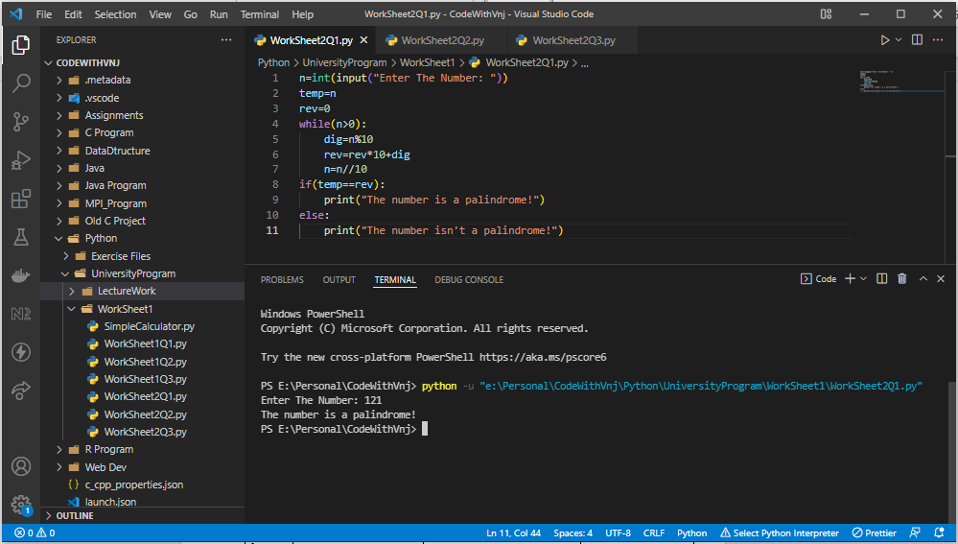

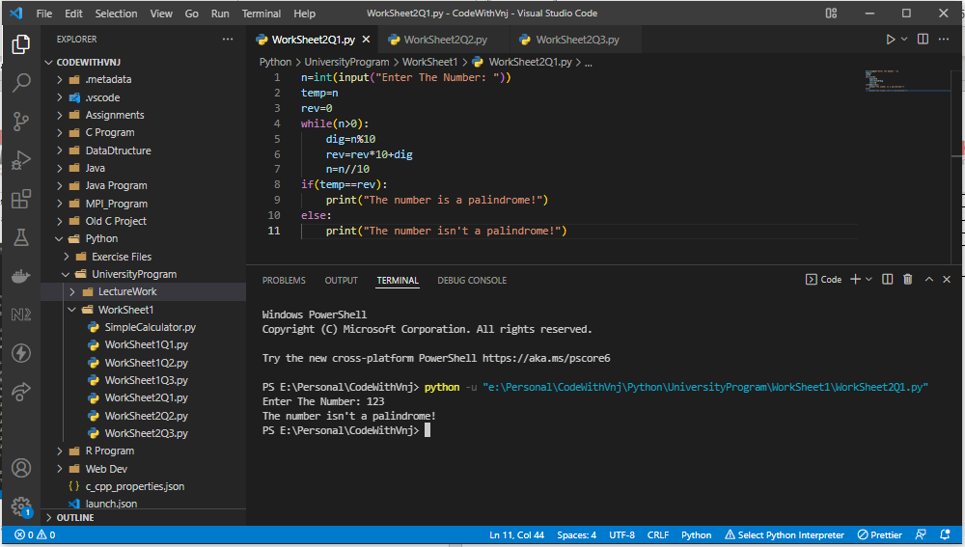

1. Check and print the Armstrong number.

**Output:**

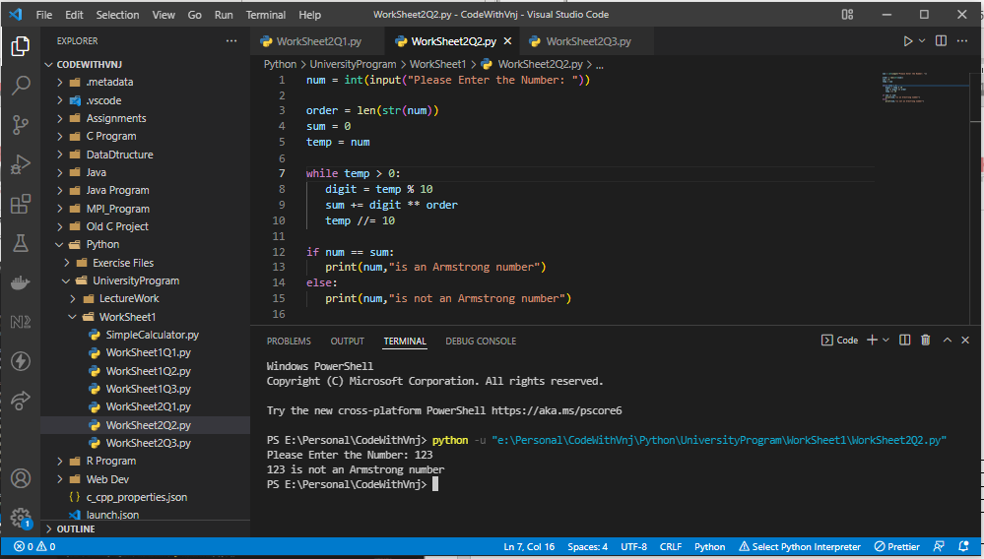

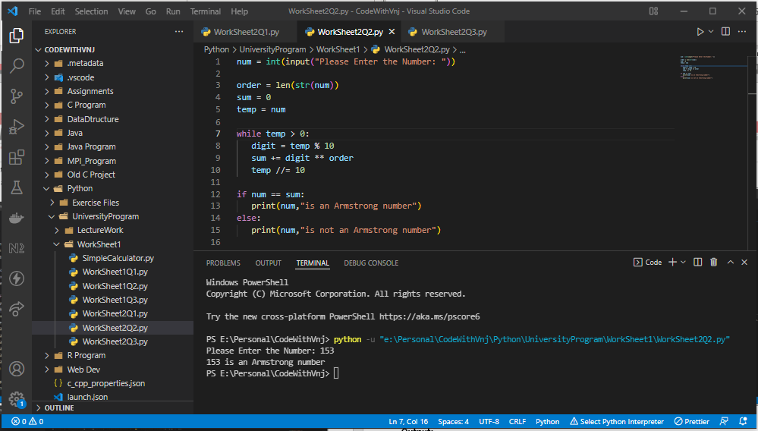

1. **C**heck and print greatest number.

**Output:**

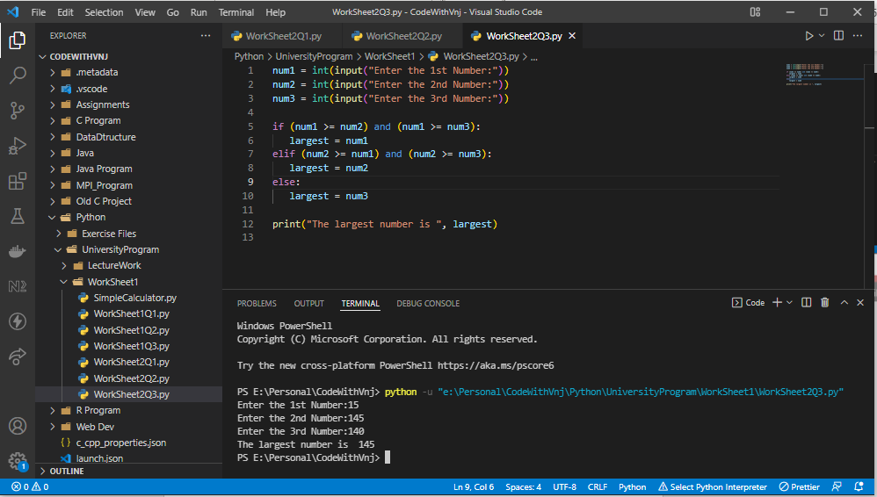

**Learning outcomes (What I have learnt):**

**1.** I have learnt, how to find Armstrong Number.

**2.** Learnt to find the Palindrome number.

**3.** Learnt to find the Largest number.

**Evaluation Grid (To be created as per the SOP and Assessment guidelines by the faculty):**

|  |  |  |  |
| --- | --- | --- | --- |
| Sr. No. | Parameters | Marks Obtained | Maximum Marks |
| 1. |  |  |  |
| 2. |  |  |  |
| 3. |  |  |  |
|  |  |  |  |